|  |  |  |  |
| --- | --- | --- | --- |
| **Name:** |  | **Date Completed:** |  |

|  |  |
| --- | --- |
| 1. **List the three hazards you would associate with Working at Height?** | |
|  |  |
|  |  |
|  |  |

|  |  |  |
| --- | --- | --- |
| 1. **Highlight risks might you suffer if Working at Height?** | | |
| Death | Damage to premise |
| A fear of heights | Serious Injury |

|  |  |  |
| --- | --- | --- |
| 1. **List three of your responsibilities** | | |
|  |  |
|  |  |
|  |  |

|  |  |  |
| --- | --- | --- |
| 1. **List three things you should look at when checking a ladder** | | |
|  |  |
|  |  |
|  |  |

|  |
| --- |
| 1. **Discuss the hazards and what they could do to make this safer** |

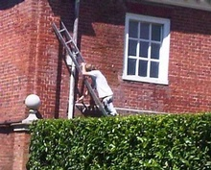

# Trainer Use Only

|  |  |  |  |  |  |
| --- | --- | --- | --- | --- | --- |
| **Marked By:** |  | | **Signature:** |  | |
| **Score:** |  | **5** | **Pass or Fail:** | Pass | Fail |