|  |  |  |  |
| --- | --- | --- | --- |
| **Name:** |  | **Date Completed:** |  |

|  |  |
| --- | --- |
| 1. **List three Slip and Trip hazards?** | |
|  |  |
|  |  |
|  |  |

|  |  |  |
| --- | --- | --- |
| 1. **What areas of a building are common for Slips and Trips?** | | |
| Toilet | Stairs |
| Reception | Everywhere |

|  |  |  |
| --- | --- | --- |
| 1. **List five things you can do to prevent Slips and Trips** | | |
|  |  |
|  |  |
|  |  |
|  |  |
|  |  |

|  |
| --- |
| 1. **Identify the hazards and how these relate to your work activities** |

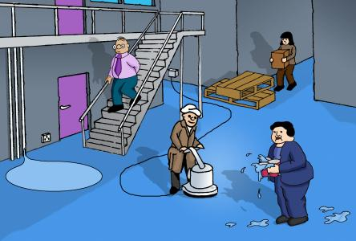

# Trainer Use Only

|  |  |  |  |  |  |
| --- | --- | --- | --- | --- | --- |
| **Marked By:** |  | | **Signature:** |  | |
| **Score:** |  | **5** | **Pass or Fail:** | Pass | Fail |